**LIVER PATIENT ANALYSIS**

**-Team Stark**

**LIVER PATIENT ANALYSIS PROJECT**

**Introduction for Python**

Python is a very powerful programming language used for many different applications. Over time, the huge community around this open source language has created quite a few tools to efficiently work with Python. In recent years, a number of tools have been built specifically for data science. As a result, analysing data with Python has never been easier. Python is a programming language that lets you work quickly and integrate systems more efficiently. There are two major Python versions- **Python 2 and Python 3**.

Both are quite different. Python is a [multi-paradigm programming language](https://en.wikipedia.org/wiki/Multi-paradigm_programming_language). [Object-oriented programming](https://en.wikipedia.org/wiki/Object-oriented_programming) and [structured programming](https://en.wikipedia.org/wiki/Structured_programming) are fully supported, and many of its features support [functional programming](https://en.wikipedia.org/wiki/Functional_programming) and [aspect-oriented programming](https://en.wikipedia.org/wiki/Aspect-oriented_programming).

Many other paradigms are supported via extensions, including [design by contract](https://en.wikipedia.org/wiki/Design_by_contract) and [logic programming](https://en.wikipedia.org/wiki/Logic_programming). Python uses [dynamic typing](https://en.wikipedia.org/wiki/Dynamic_typing), and a combination of [reference counting](https://en.wikipedia.org/wiki/Reference_counting) and a cycle-detecting garbage collector for [memory management](https://en.wikipedia.org/wiki/Memory_management). It also features dynamic [name resolution](https://en.wikipedia.org/wiki/Name_resolution_(programming_languages)) ([late binding](https://en.wikipedia.org/wiki/Late_binding)), which binds method and variable names during program execution.Python's design offers some support for [functional programming](https://en.wikipedia.org/wiki/Functional_programming) in the [Lisp](https://en.wikipedia.org/wiki/Lisp_(programming_language)) tradition. It has filter, map, and reduce functions; [list comprehensions](https://en.wikipedia.org/wiki/List_comprehension), [dictionaries](https://en.wikipedia.org/wiki/Associative_array), sets end [generator](https://en.wikipedia.org/wiki/Generator_(computer_programming)) expressions.

 The standard library has two modules (itertools and functools) that implement functional tools borrowed from [Haskell](https://en.wikipedia.org/wiki/Haskell_(programming_language)) and [Standard ML](https://en.wikipedia.org/wiki/Standard_ML). Python is meant to be an easily readable language. Its formatting is visually uncluttered, and it often uses English keywords where other languages use punctuation. Unlike many other languages, it does not use [curly brackets](https://en.wikipedia.org/wiki/Curly_bracket_programming_language) to delimit blocks, and semicolons after statements are optional. It has fewer syntactic exceptions and special cases than [C](https://en.wikipedia.org/wiki/C_(programming_language)) or [Pascal](https://en.wikipedia.org/wiki/Pascal_(programming_language))

**Introduction for Machine learning**

**AI Machine learning**  is the [scientific study](https://en.wikipedia.org/wiki/Branches_of_science) of [algorithms](https://en.wikipedia.org/wiki/Algorithm) and [statistical models](https://en.wikipedia.org/wiki/Statistical_model) that [computer systems](https://en.wikipedia.org/wiki/Computer_systems) use in order to perform a specific task effectively without using explicit instructions, relying on patterns and inference instead. It is seen as a subset of [artificial intelligence](https://en.wikipedia.org/wiki/Artificial_intelligence). Machine learning algorithms build a [mathematical model](https://en.wikipedia.org/wiki/Mathematical_model) based on sample data, known as "[training data](https://en.wikipedia.org/wiki/Training_data)", in order to make predictions or decisions without being explicitly programmed to perform the task. Machine learning algorithms are used in a wide variety of applications, such as [email filtering](https://en.wikipedia.org/wiki/Email_filtering), and [computer vision](https://en.wikipedia.org/wiki/Computer_vision), where it is infeasible to develop an algorithm of specific instructions for performing the task. Machine learning is closely related to [computational statistics](https://en.wikipedia.org/wiki/Computational_statistics), which focuses on making predictions using computers.

The study of [mathematical optimization](https://en.wikipedia.org/wiki/Mathematical_optimization) delivers methods, theory and application domains to the field of machine learning. Machine learning tasks are classified into several broad categories. In [supervised learning](https://en.wikipedia.org/wiki/Supervised_learning), the algorithm builds a mathematical model from a set of data that contains both the inputs and the desired outputs. For example, if the task were determining whether an image contained a certain object, the [training data](https://en.wikipedia.org/wiki/Training_data) for a supervised learning algorithm would include images with and without that object (the input), and each image would have a label (the output) designating whether it contained the object. In special cases, the input may be only partially available, or restricted to special feedback. [Classification](https://en.wikipedia.org/wiki/Statistical_classification) algorithms and [regression](https://en.wikipedia.org/wiki/Regression_analysis) algorithms are types of supervised learning.

Classification algorithms are used when the outputs are restricted to a [limited set](https://en.wikipedia.org/wiki/Discrete_number) of values. For a classification algorithm that filters emails, the input would be an incoming email, and the output would be the name of the folder in which to file the email.  [Regression](https://en.wikipedia.org/wiki/Regression_analysis) algorithms are named for their continuous outputs, meaning they may have any value within a range. Examples of a continuous value are the temperature, length, or price of an object. In [unsupervised learning](https://en.wikipedia.org/wiki/Unsupervised_learning), the algorithm builds a mathematical model from a set of data which contains only inputs and no desired output labels. Unsupervised learning algorithms are used to find structure in the data, like grouping or [clustering](https://en.wikipedia.org/wiki/Cluster_analysis) of data points. Unsupervised learning can discover patterns in the data, and can group the inputs into categories

**Objectives of Research**

In India, delayed diagnosis of diseases is a fundamental problem due to a shortage of medical professionals. A typical scenario, prevalent mostly in rural and somewhat in urban areas is:

1. A patient going to a doctor with certain symptoms.

2. The doctor recommending certain tests like blood test, urine test etc depending on the symptoms.

3. The patient taking the aforementioned tests in an analysis lab.

4. The patient taking the reports back to the reports back to the hospital, where they are examined and the disease is identified.

The aim of this project is to somewhat reduce the time delay caused due to the unnecessary back and forth shuttling between the hospital and the pathology lab.A machine learning algorithm will be trained to predict a liver disease in patients.

**Problem Statement**

The problem statement is formally defined as:

‘Given a dataset containing various attributes of 584 Indian patients, use the features available in the dataset and define a supervised classification algorithm which can identify whether a person is suffering from liver disease or not. This data set contains 416 liver patient records and 167 non- liver patient records.The data set was collected from north east of Andhra Pradesh, India. This data set contains 441 male patient records and 142 female patient records. Any patient whose age exceeded 89 is listed as being of age "90".

**Strategy**

This seems to be a classic example of supervised learning. We have been provided with a fixed number of features for each data point, and our aim will be to train a variety of Supervised Learning algorithms on this data, so that , when a new data point arises, our best performing classifier can be used to categorize the data point as a positive example or negative. Exact details of the number and types of algorithms used for training is included in the 'Algorithms and Techniques' sub-section of the 'Analysis' part.

**Metrics**

In problems of disease classification like this one, simply comparing the accuracy, that is, the ratio of correct predictions to total predictions is not enough. This is because depending on the context like severity of disease, sometimes it is more important that an algorithm does not wrongly predict a disease as a non-disease, while predicting a healthy person as diseased will attract a comparatively less severe penalty.

Thus, here we will use **F-beta score** as a performance metric, which is basically the weighted harmonic mean of precision and recall. Precision and Recall are defined as:

Precision=TP/ (TP+FP), Recall=TP/ (TP+FN), where

TP=True Positive

FP=False Positive

FN=False Negative

In the same vein, F-beta score is:

F-beta score = (1+β2*)\**precision*recall/(( β 2*precision)+recall)

β = A number that decides relative weightage of precision and recall. In this case, a disease being classified as a non-disease will incur a high penalty. So, more emphasis is placed on recall.

Additionally, one more metric called as Receiver Operating Characteristics (ROC) curve will be used. It plots the curve of True Positive Rate vs the False Positive Rate for a given algorithm, with a greater area under the curve indicating a better True Positive Rate for the same False Positive Rate, indicating the usefulness of the classifier.

**Project Overview**

In India, delayed diagnosis of diseases is a fundamental problem due to a shortage of medical professionals. A typical scenario, prevalent mostly in rural and somewhat in urban areas is:

1. A patient going to a doctor with certain symptoms.
2. The doctor recommending certain tests like blood test, urine test etc depending on the symptoms.
3. The patient taking the aforementioned tests in an analysis lab.
4. The patient taking the reports back to the reports back to the hospital, where they are examined and the disease is identified.

The aim of this project is to somewhat reduce the time delay caused due to the unnecessary back and forth shuttling between the hospital and the pathology lab. Historically, work has been done in identifying the onset of diseases like heart disease, Parkinson's from various features a machine learning algorithm will be trained to predict a liver disease in patients.

**Review of literature**

This seems to be a classic example of supervised learning. We have been provided with a fixed number of features for each data point, and our aim will be to train a variety of Supervised Learning algorithms on this data, so that , when a new data point arises, our best performing classifier can be used to categorize the data point as a positive example or negative. Exact details of the number and types of algorithms used for training is included in the 'Algorithms and Techniques' sub-section of the 'Analysis' part.

**Data Table**

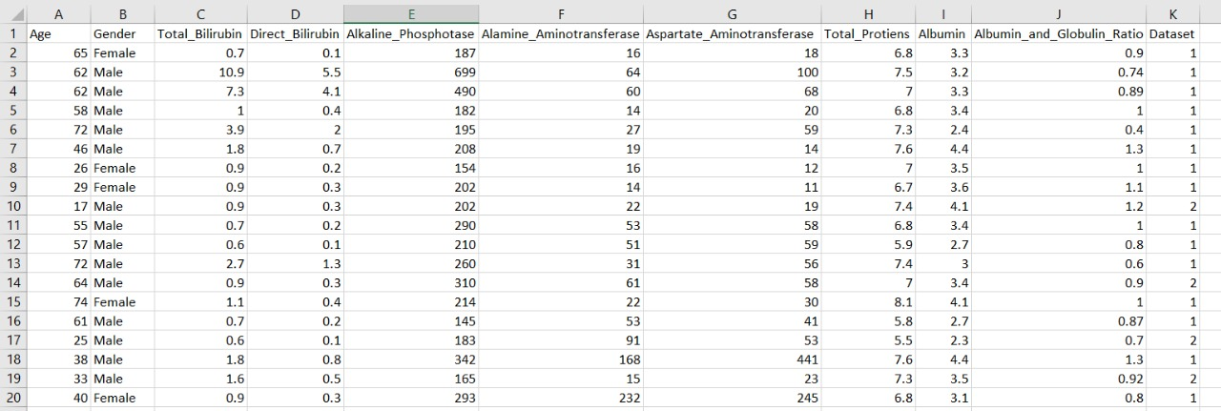

**Context**

Patients with Liver disease have been continuously increasing because of excessive consumption of alcohol, inhale of harmful gases, intake of contaminated food, pickles and drugs. This dataset was used to evaluate prediction algorithms in an effort to reduce burden on doctors.

**Content**

This data set contains 416 liver patient records and 167 non liver patient records collected from North East of Andhra Pradesh, India. The "Dataset" column is a class label used to divide groups into liver patient (liver disease) or not (no disease). This data set contains 441 male patient records and 142 female patient records. Any patient whose age exceeded 89 is listed as being of age "90".

**Columns:**

* Age of the patient
* Gender of the patient
* Total Bilirubin
* Direct Bilirubin
* Alkaline Phosphotase
* Alamine Aminotransferase
* Aspartate Aminotransferase
* Total Protiens
* Albumin
* Albumin and Globulin Ratio
* Dataset: field used to split the data into two sets (patient with liver disease, or no disease)

**Methodology**

In problems of disease classification like this one, simply comparing the accuracy, that is, the ratio of correct predictions to total predictions is not enough. This is because depending on the context like severity of disease, sometimes it is more important that an algorithm does not wrongly predict a disease as a non-disease, while predicting a healthy person as diseased will attract a comparatively less severe penalty. Thus, here we will use **F-beta score** as a performance metric, which is basically the weighted harmonic mean of precision and recall. Precision and Recall are defined as:

Precision=TP/ (TP+FP), Recall=TP/ (TP+FN), where

TP=True Positive

FP=False Positive

FN=False Negative

In the same vein, F-beta score is:

F-beta score = (1+β2*)\**precision*recall/(( β 2*precision)+recall)

**Exploratory Data Analysis**

**COUNT PLOT OF LIVER PATIENTS DIAGNOISED**

Number of patients diagnosed with liver disease: 416

Number of patients not diagnosed with liver disease: 167

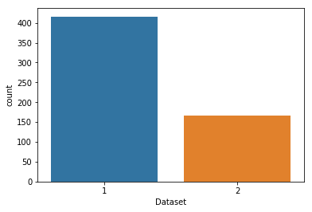

**COUNT PLOT OF MALE & FEMALE PATIENTS**

Number of patients that are male: 441

Number of patients that are female: 142

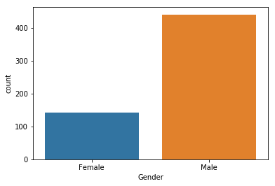

**FACETGRID ON DISEASE BY GENDER AND AGE**

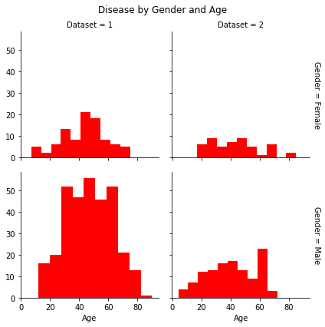

**CATPLOT BASED ON AGE, GENDER & DATASET**

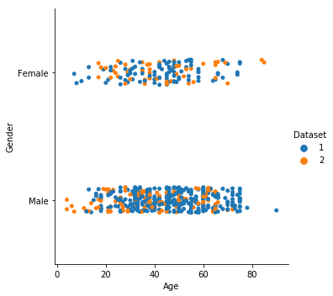

**FACETGRID ON DIRECT_BILIRUBIN &TOTAL_BILIRUBIN**

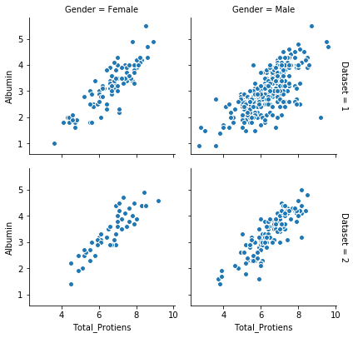

**JOINTPLOT ON DIRECT_BILIRUBIN &TOTAL_BILIRUBIN**

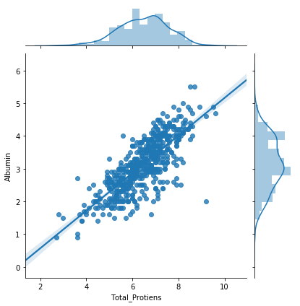

**CO-RELATION GRAPGH**

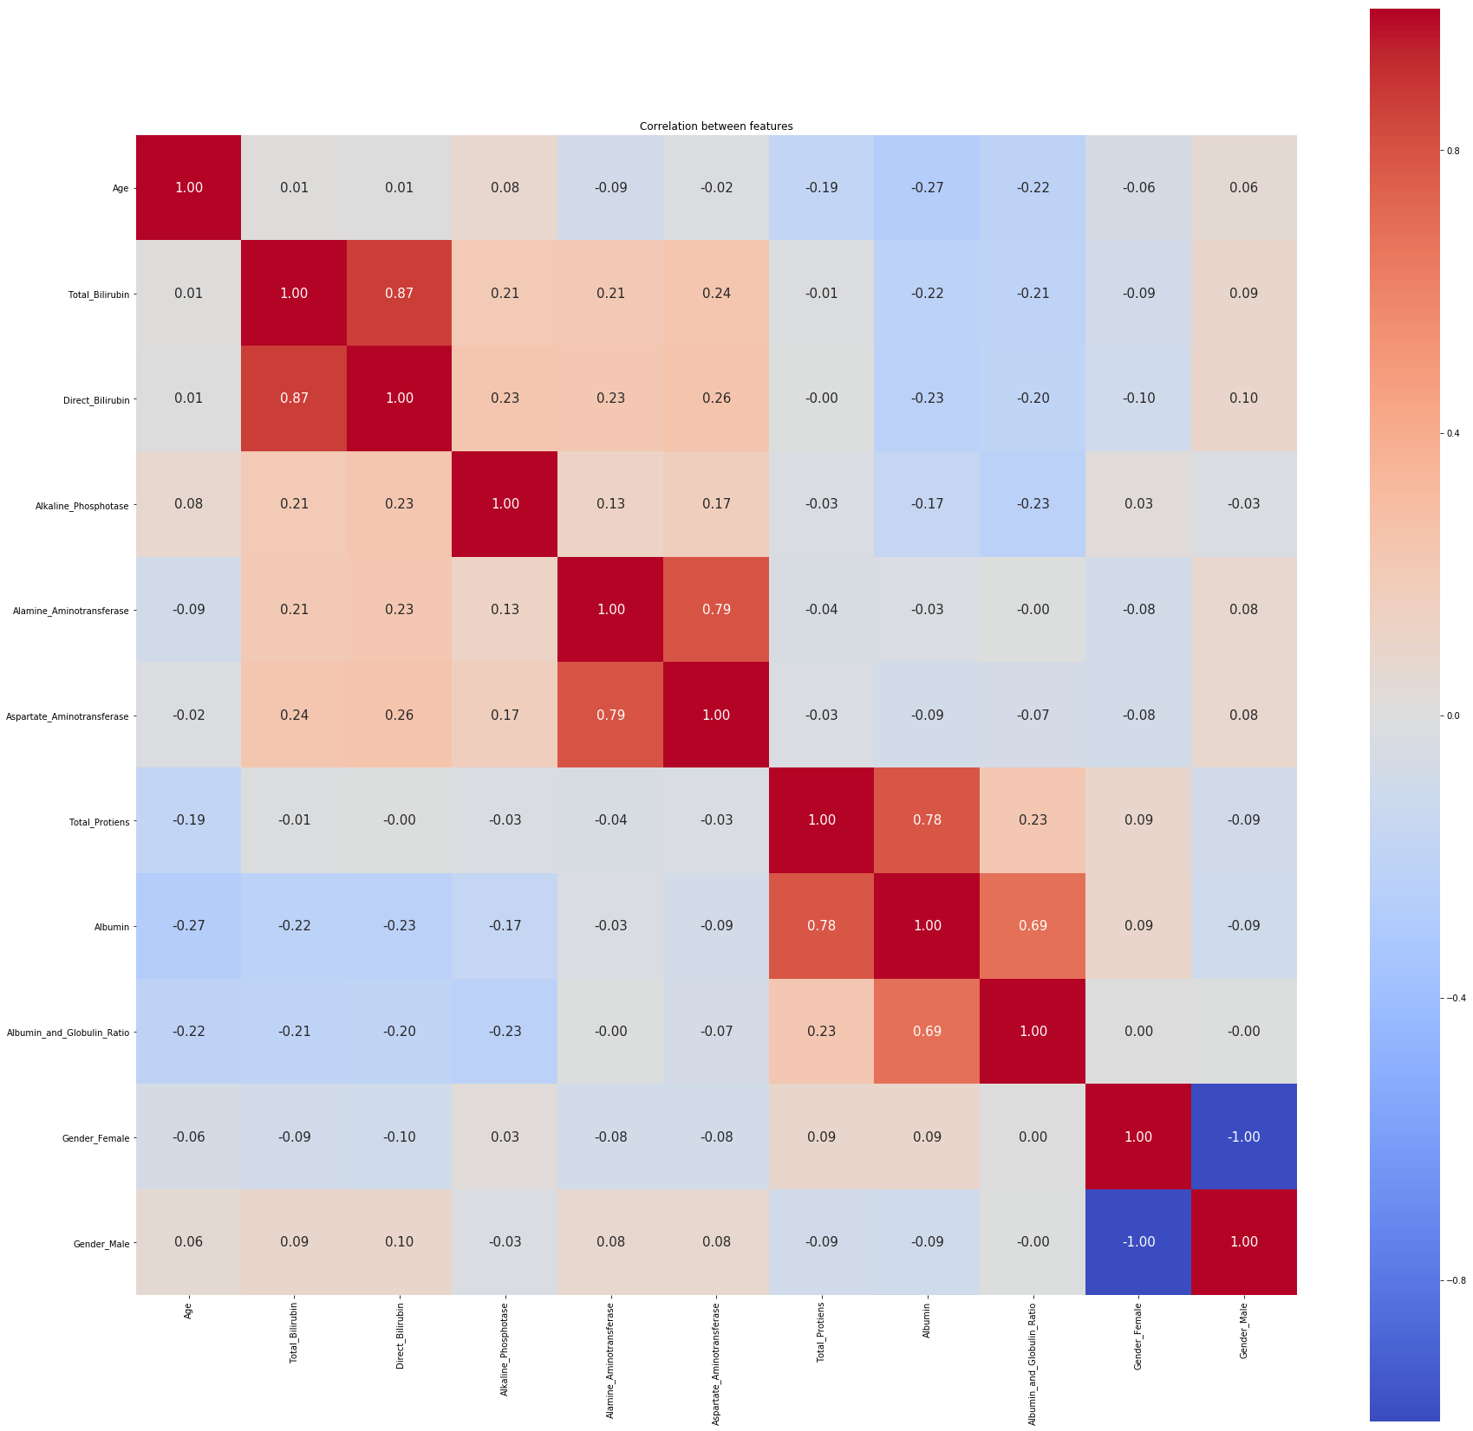

**Algorithms and Techniques**

Three supervised learning approaches are selected for this problem. Care is taken that all these approaches are fundamentally different from each other, so that we can cover as wide an umbrella as possible in term of possible approaches. For example- We will not select Random Forest and Ada Boost together as they come from the same family of ‘ensemble’ approaches:

For each algorithm, we will try out different values of a few hyperparameters to arrive at the best possible classifier. This will be carried out with the help of grid search cross validation technique. The algorithms are described below:

1. **Random Forest Classifier:**

* n_estimators(number of trees in a forest)
* max_depth(maximum depth of one single tree)
* max_features(decides how many features are to be used)
* oob_score(decides whether to include out-of-bag or prediction error )

**Accuracy scored: 0.68**

## **Gaussian Naive Bayes Classifier**

Naive Bayes is a classification algorithm for binary (two-class) and multi-class classification problems. The technique is easiest to understand when described using binary or categorical input values. The representation for naive Bayes is probabilities. A list of probabilities are stored to file for a learned naive Bayes model. This includes:

**Class Probabilities**: The probabilities of each class in the training dataset.

**Conditional Probabilities**: The conditional probabilities of each input value given each class value.

**Accuracy scored: 0.5613**

1. **Logistic Regression**:

Since the outcome is binary and we have a reasonable number of examples at our disposal compared to number of features, this approach seems suitable. At the core of this method is a logistic or sigmoid function that quantifies the difference between each prediction and its corresponding true value. When presented with a number of inputs, it assigns different weights to features (based on their relative importance).

Since for this data it already knows the output beforehand, it continuously adjusts the weights such that when these weights summed up with their features are introduced in the logistic function, the results are as near as possible to the actual ones. Once presented with a test value, it again inserts the value into our logistic function and returns the output as a number between 0 and 1, which represents the probability of that test value being in a particular class.

**Accuracy scored: 0.7143**

**Findings and Suggestions**

The dataset for this problem is the ILPD (Indian Liver Patient Dataset) taken from the UCI Machine Learning Repository. Region specified in this dataset is of Andhra Pradesh of year 2017.

As our dataset is small it’s training dataset is similar to test dataset so we cannot rely on this model for predicting accuracy for large dataset. We need more precised data set containing larger values and attributes to classify values and get best accuracy

**Conclusion**

Initially, the dataset was explored and made ready to be fed into the classifiers. This was achieved by removing some rows containing null values, transforming some columns which were showing skewness and using appropriate methods (one-hot encoding) to convert the labels so that they can be useful for classification purposes. Performance metrics on which the models would be evaluated were decided. The dataset was then split into a training and testing set.

Firstly, a naive predictor and a benchmark model ('Logistic Regression') were run on the dataset to determine the benchmark value of accuracy. The greatest difficulty in the execution of this project was faced in two areas- determining the algorithms for training and choosing proper parameters for fine-tuning. Initially, I found it very vexing to decide upon 3 or 4 techniques out of the numerous options available in sklearn.

This exercise made me realize that parameter tuning is not only a very interesting but also a very important part of machine learning. I think this area can warrant further improvement, if we are willing to invest a greater amount of time as well as computing power.